**Summing over tensor dimensions**

You've been given a matrix, wealth. This contains the value of bond and stock wealth for five individuals in thousands of dollars.

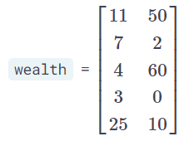

The first column corresponds to bonds and the second corresponds to stocks. Each row gives the bond and stock wealth for a single individual. Use wealth, reduce_sum(), and .numpy() to determine which statements are correct about wealth.

##### Instructions

**50 XP**

##### Possible Answers

* 

The individual in the first row has the highest total wealth (i.e. stocks + bonds).

* 

Combined, the 5 individuals hold $50,000 in stocks.

* 

Combined, the 5 individuals hold $50,000 in bonds.

* 

The individual in the second row has the lowest total wealth (i.e. stocks + bonds).

###### Hint

* reduce_sum(wealth,1) will sum wealth over its rows.
* reduce_sum(wealth,0) will sum wealth over its columns.
* Note bonds appear first and stocks appear second in reduce_sum(wealth,0).
* You can append .numpy() to reduce_sum() to convert the results to a numpy array.

Excellent work! Understanding how to sum over tensor dimensions will be helpful when preparing datasets and training models.